

**NATIONAL CERTIFICATE**

**INDUSTRIAL INSTRUMENTS N5**

(8080205)

**23 July 2021 (X-paper)**

**09:00–12:00**

**Drawing instruments and nonprogrammable calculators may be used.**

**This question paper consists of 6 pages and a formula sheet of 2 pages.**

007Q1G2123

Please turn over

**DEPARTMENT OF HIGHER EDUCATION AND TRAINING**

**REPUBLIC OF SOUTH AFRICA**

NATIONAL CERTIFICATE

INDUSTRIAL INSTRUMENTS N5

TIME: 3 HOURS

MARKS: 100

## INSTRUCTIONS AND INFORMATION

1. Answer all the questions.

1. Read all the questions carefully.

1. Number the answers according to the numbering system used in this question paper.

1. Start each question on a new page.

1. Use only a black or blue pen.

1. Write neatly and legibly.

**SECTION A: FLOW MEASUREMENT**

## QUESTION 1

Indicate whether the following statements are TRUE or FALSE by writing only 'True' or 'False' next to the question number (1.1–1.7) in the ANSWER BOOK.

1.1 Bernoulli's equation is a mathematical expression of fluid density and compressibility in a restriction.



1.2 Turbine flow-measuring elements are inherently linear and require no square root extraction anywhere in the loop.

1.3 As incompressible fluid moves through a restriction, velocity increases and pressure remains the same.

1.4 For accurate operation, orifice plate flowmeters require fully developed turbulent flow.



1.5 Thermal flowmeters inherently measure maximum flow rate.

1.6 A magnetic flowmeter will properly measure the flow rate of oil.

1.7 A flag flapping in a breeze illustrates vortex shedding of dynamic fluid effects.

(7 × 1)  **[7]**

## QUESTION 2

2.1 Name the instrument shown in FIGURE 1 below. (1)

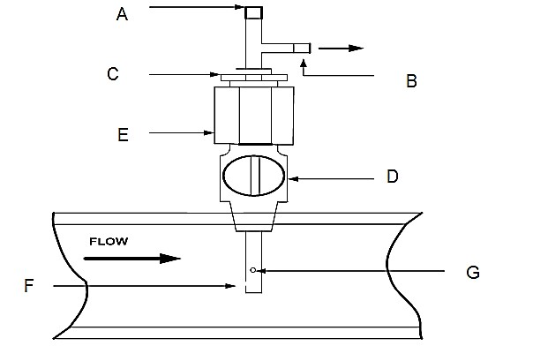

# FIGURE 1

2.1.1 Name components A to G. (7)

2.1.2 Explain *stagnation point*. (3)



2.2 Flowmeters are generally divided into two parts.

Name these parts. (2)

2.3 If a pipe decreases from a 9 cm diameter to 6 cm diameter and the velocity in the 9 cm section is 2,21 m/s, what is the average velocity in the 6 cm section?

**HINT:** Continuity requires that the flow rate is constant: *A*1*v*1 =*A*2*v*2 (7)

2.4 Weirs are used to measure flow rate primarily on open channels such as water works including irrigation, waste and sewage systems, and in pipes and conduits that are generally not completely filled with water. It is an obstruction in a flowing stream over which the liquid is forced to pass.



2.4.1 State THREE advantages and TWO disadvantages of weirs. (5)

2.4.2 Name THREE types of weirs. (3)

**[28]**

**TOTAL SECTION A:**  **35**

**SECTION B: DENSITY, HUMIDITY AND VISCOSITY MEASUREMENT**

## QUESTION 3

3.1 Make a neat, labelled sketch of a displacement type hygrometer. (5)

3.2 Explain *the principle of operation* *of a sliding plate viscometer.* (7)



|  |  |  |
| --- | --- | --- |
| 3.3 | Explain, with the aid of a sketch, *the operation of a dew-cell hygrometer.* | (12) **[24]** |
|  | **TOTAL SECTION B:** | **24** |

**SECTION C: pH AND CONDUCTIVITY MEASUREMENT**

# QUESTION 4

4.1 Make a neat, labelled sketch of a calomel reference electrode used in the

measurement of pH. (6)



4.2 Explain what is meant by a pH measurement flow assembly. (3)

4.3 Study FIGURE 2 below and label components A to G.

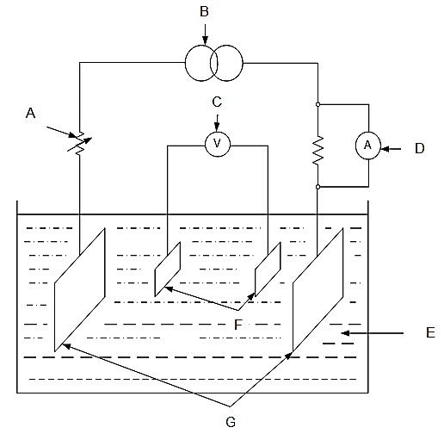

(7)

**FIGURE 2**  **[16]**

**TOTAL SECTION C:**  **16**

**SECTION D: AUTOMATIC CONTROL**

## QUESTION 5

5.1 Make neat, labelled sketches of a three-term (PID) position-balance controller

and briefly explain its working principle. (10)



5.2 Explain *cascade* *control-loop* *systems* with the aid of a labelled sketch. (10)

5.3 Name FIVE types of control. (5)

**[25]**

**TOTAL SECTION D:**  **25**  **GRAND TOTAL:**  **100**

-1-

**INDUSTRIAL INSTRUMENTS N5**

## FORMULA SHEET

Any other applicable formulas may be used.

|  |  |  |  |
| --- | --- | --- | --- |
| *W* = 3592*CZ**Ed* 2 | *(h*) | *ρ* | *Rd* =*W*/158*d* |

*Q* = 3592*CZ**Ed* 2*(h*) *ρ Rd* = *Q*/158*d*

|  |  |  |
| --- | --- | --- |
|  |  |  |
| *Qg* = 2238 *CZEd*2 | (*h*/) | *Rd* = *Qg*/986 *d* |
| *m* = (*d* /*D*)2 |  | *E* =1/(1 − *m*2) |

*W* = 001252 *CZ**Ed*2(*h*) *Rd* = 354*W*/*d*

*Rd* = 354*Qd*/*d*

*Q* = 001252 *CZ**Ed*2 (*h*/) *E* =1/(1 − *m*2)

*m* = (*d*/*D*)2

*W Q* ()

*N* = 2 (*h*) = 001252 *D*2 (*h*)

001252 *D*

*mE* = *N*/*CZ*

*CmE* = *N*/*Z* *mE* = *CmE*/*C*

*Rd* = 354*W* = 354*Q**D* (*m*) *D* (*m*)

*d*/*D* = [(*mE*)2/1 +(*mE*)2]

*W* =1252 *Ud*2(*P*) *for critical flow*

*d* =[*W*/1252*U* (*P*)] *for critical flow*

*N* = *W*2 (*h*) = 359*Q*2 *D*2()(*h*) = 2238*QgD*2()(*h*)

3592 *D*

*mE*=*N*/*CZ*

*CmE*=*N*/*Z* *mE*=*CmE*/*C*

*Rd* = *W* = *Q* = *Qg*

158*D* (*m*) 158*D* (*m*) 986*D* (*m*)

*d*/*D*= [(*mE*)2/1+ (*mE*)2]

*W* =1890 *Ud*2(*P*) *for critical flow*

*d* =[*W*/1890*U* (*P*)] *for critical flow*

*1 kPa = 102 mmWD = 102 mmWC*

Please turn over

-2-

1. *lb/ft3 = 16,0183 kg/m3*

*Atmospheric pressure = 101,325 kPa*

*Gravitation acceleration = 9,81 m/s2*

*D h kPa*

*For/Vir D*+ *tappings and flange tappings*  27,2 =  27,2

1. *Pa kPa*

8  5

*Q*= *Tan* 2*g*.*H*

15 2

2 3

*Q* = 3 *B* 2*g*.*H*